**BOARD 3- GOLDEN ARDUINO**

Isha Sharma

# Objective: To build an Arduino board with better noise control.

# Board POR:

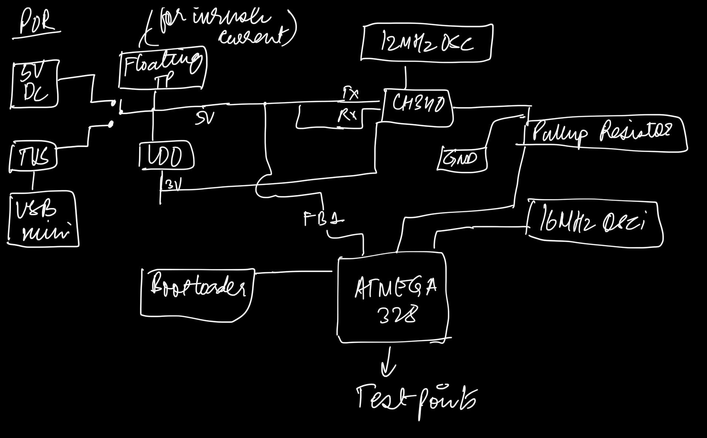

The 5v comes in from the power jack. A USB mini is used as an alternate source of power and to talk using UART. It is connected to a TVS for protection. The power input can be switched between the two. A floating test point is connected to check for inrush current values. 5V then gets converted to 3.3v using an LDO. CH340 chip is used for USB to UART conversions and hence is connected to the USB mini. It is powered by a 3.3v supply. It requires a 12 MHz crystal oscillator. The bootloader chip is used to boatload the board so it learns to act as an Arduino board. The Atmega 328 chip is the microcontroller chip used in Arduino. It required a 16 MHz oscillator. The reset is connected to a pull-up resistor and ground. The is further connected to test points and header pins.

# Expectations of output:

The board should function like a commercial Arduino board successfully but with lesser noise. For this, the following should be done: When powering the board, the indicator LEDs should light up. The bootloader should be burned successfully. Any sketch should be able to run on the board. When compared with the commercial Arduino, the switching noise when measured with the noise shield should be less. The inrush current should be within range.

# Board:

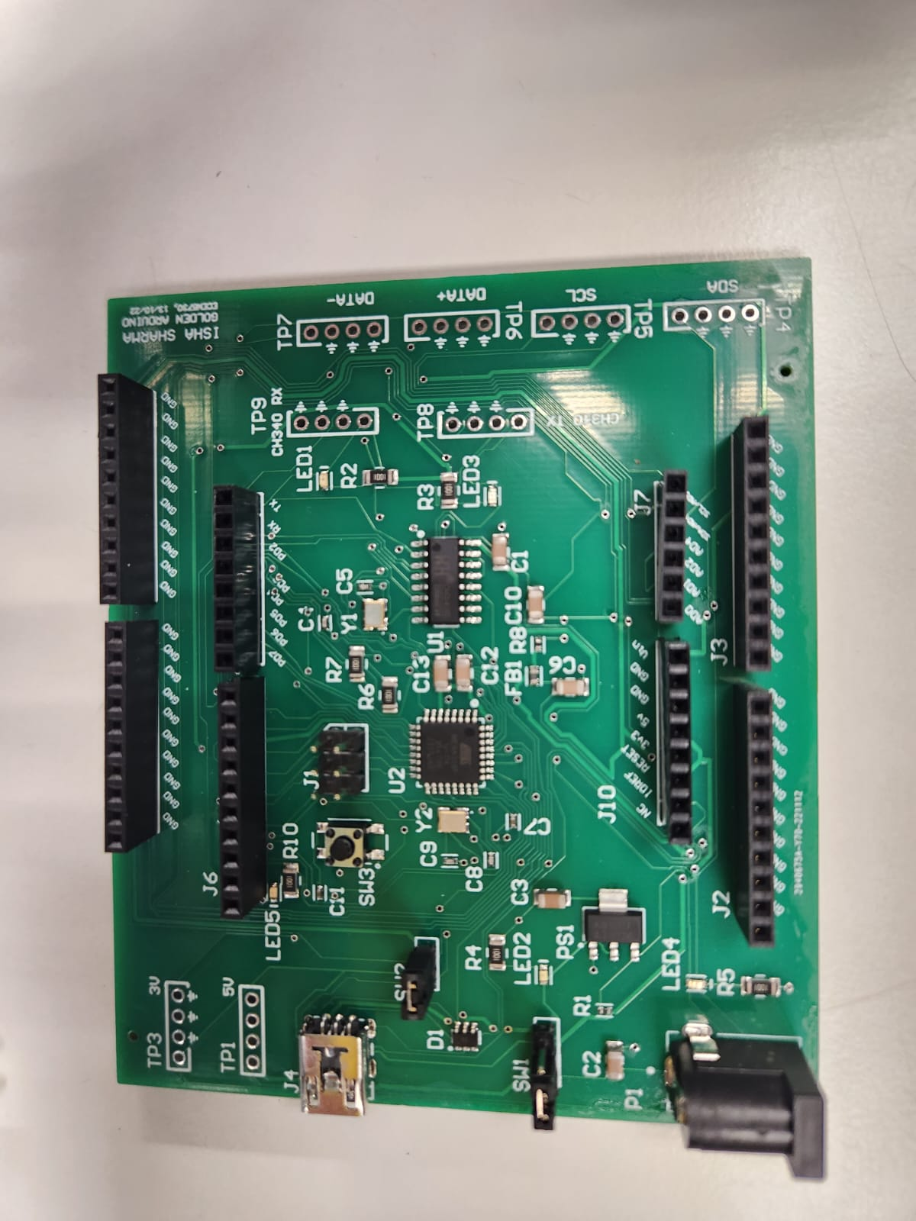

# Board Schematic:

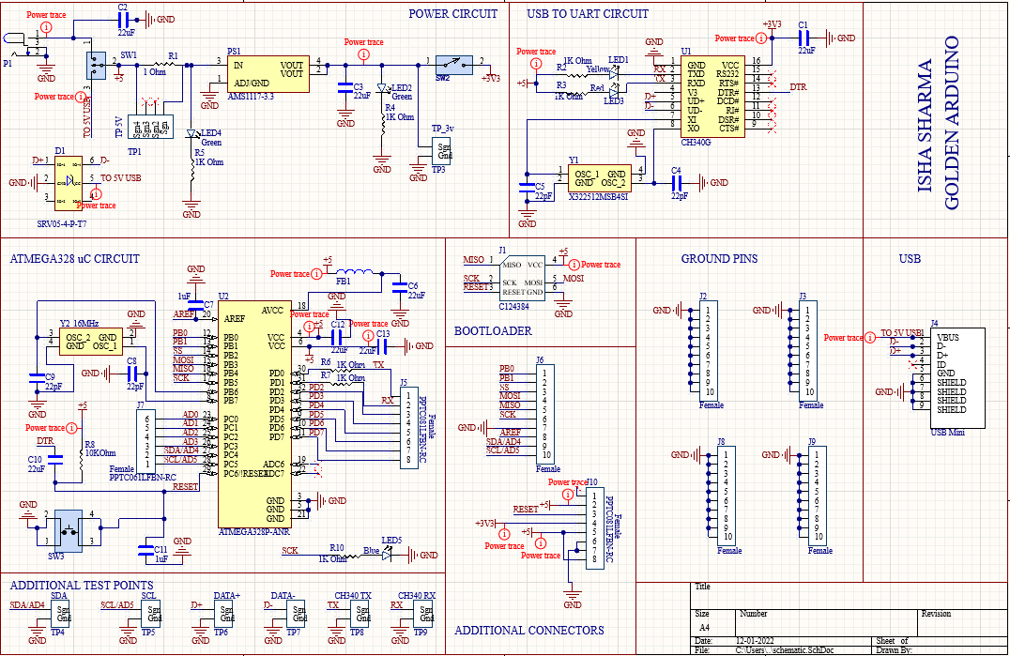

# Board Layout:

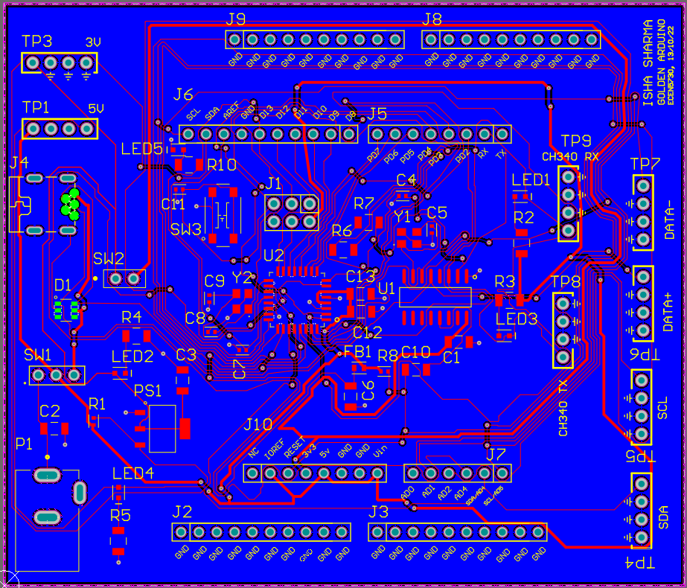

Output and Inference:

1. The board light up when powered.

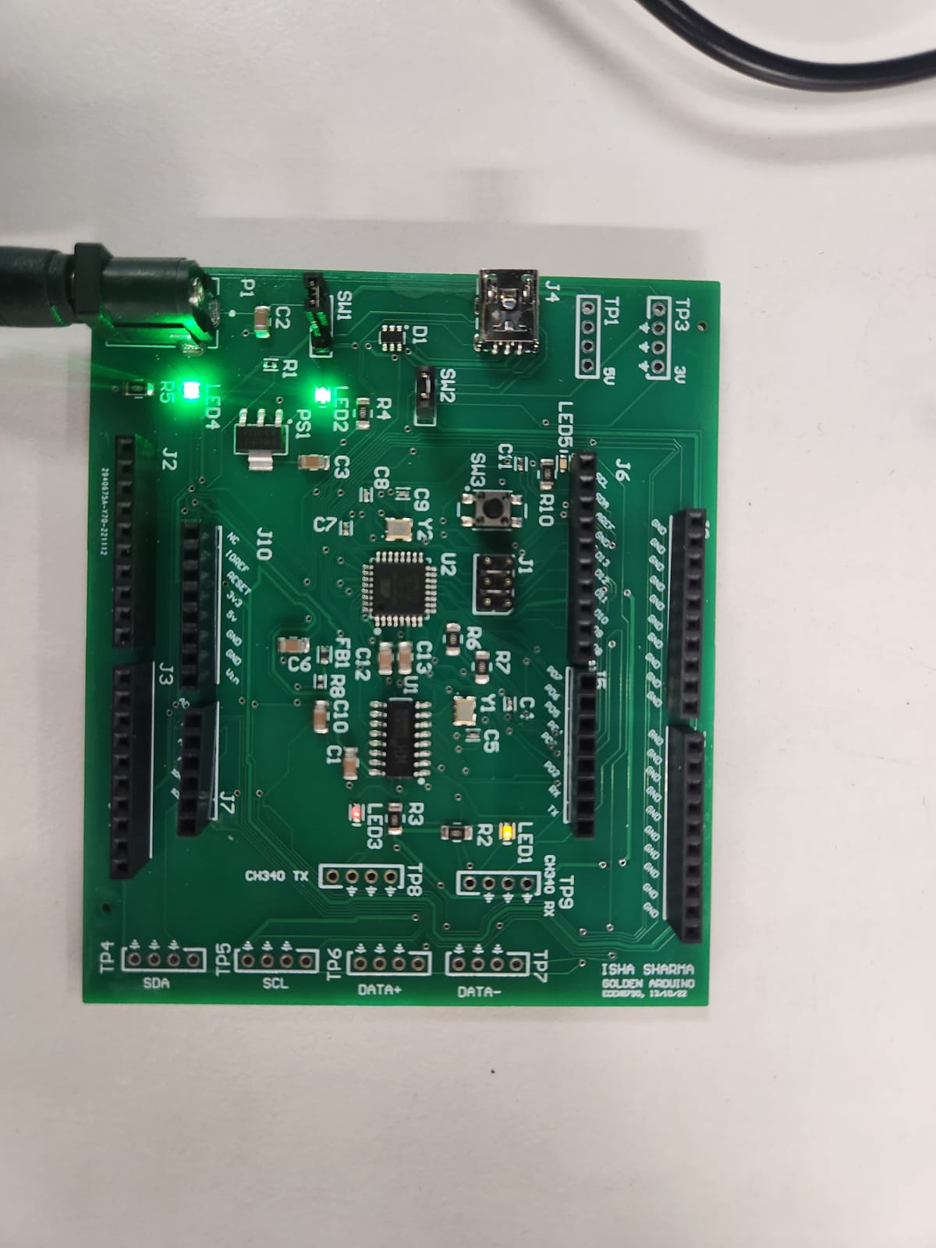

1. The board was successfully boot loaded.

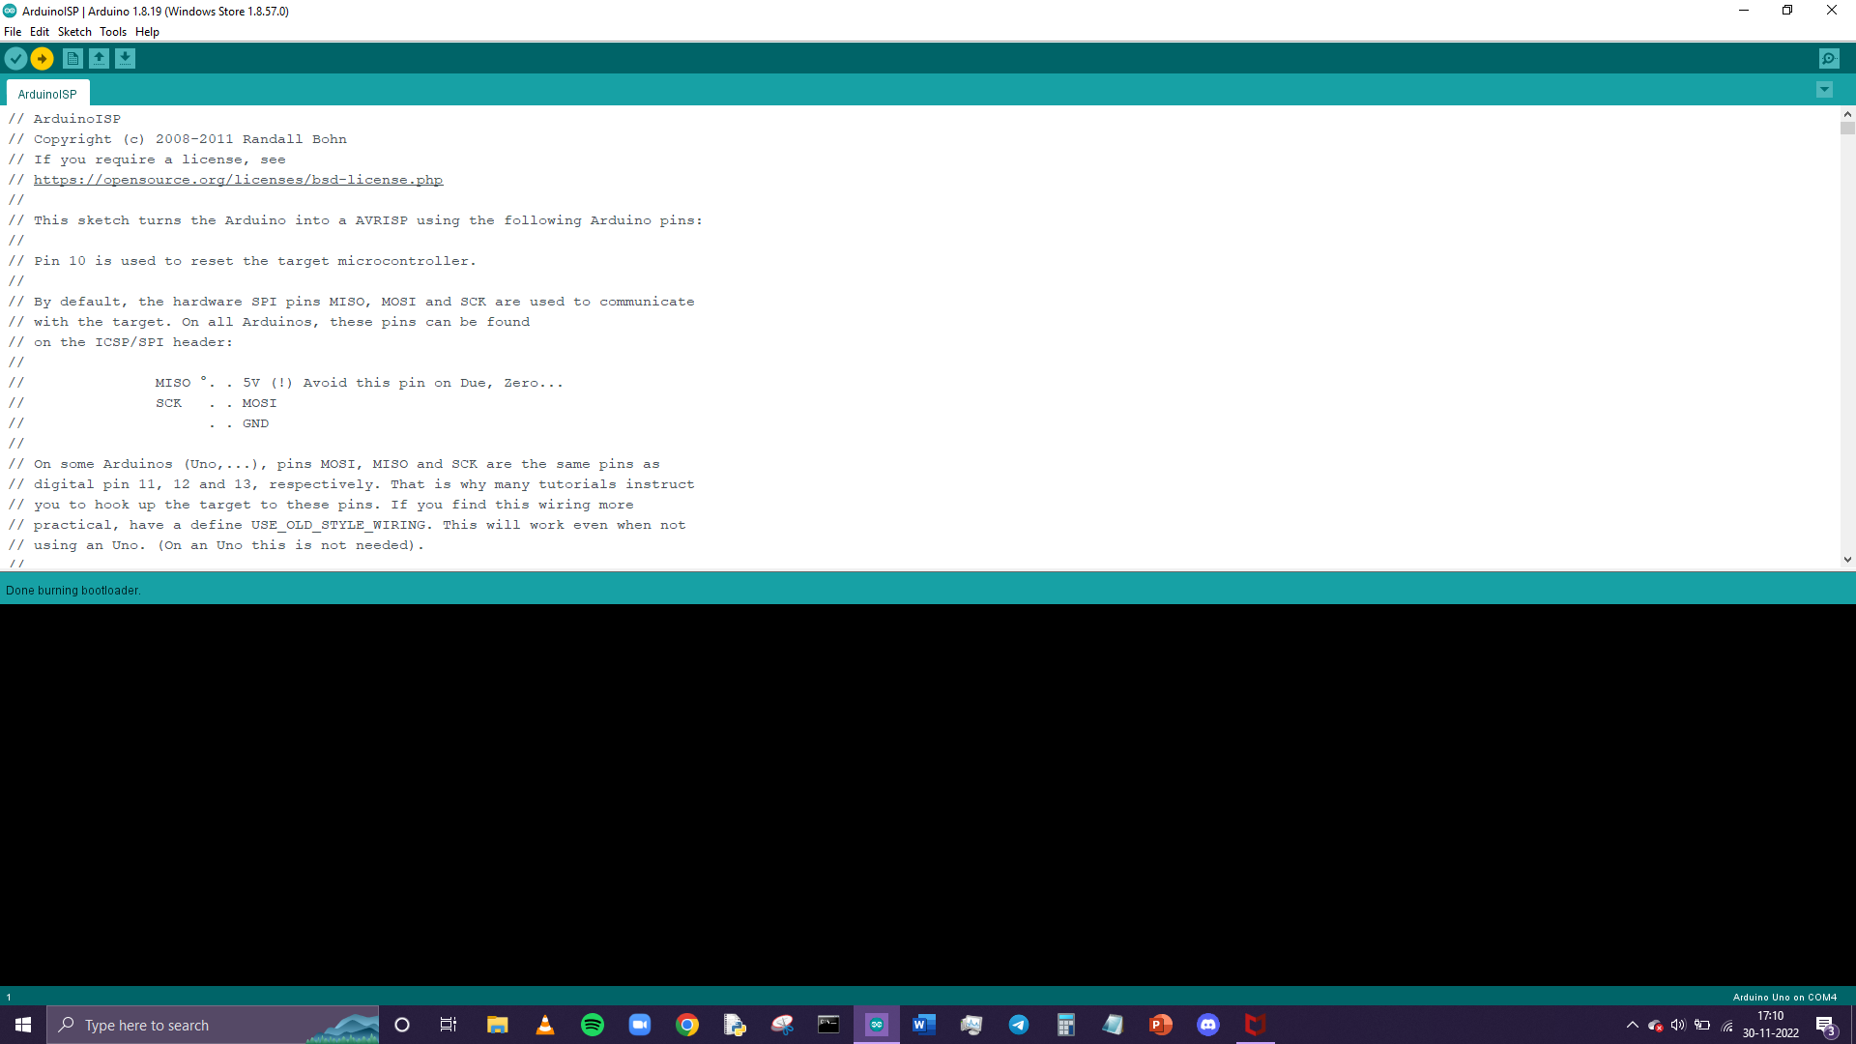

1. There was an error when trying to upload the blink sketch. After debugging, I found the i had switched the Tx ad RX connection for the 328. The error was corrected by manually removing the 1Kohm resistors for Tx and Rx and inverting the connection via wires.

 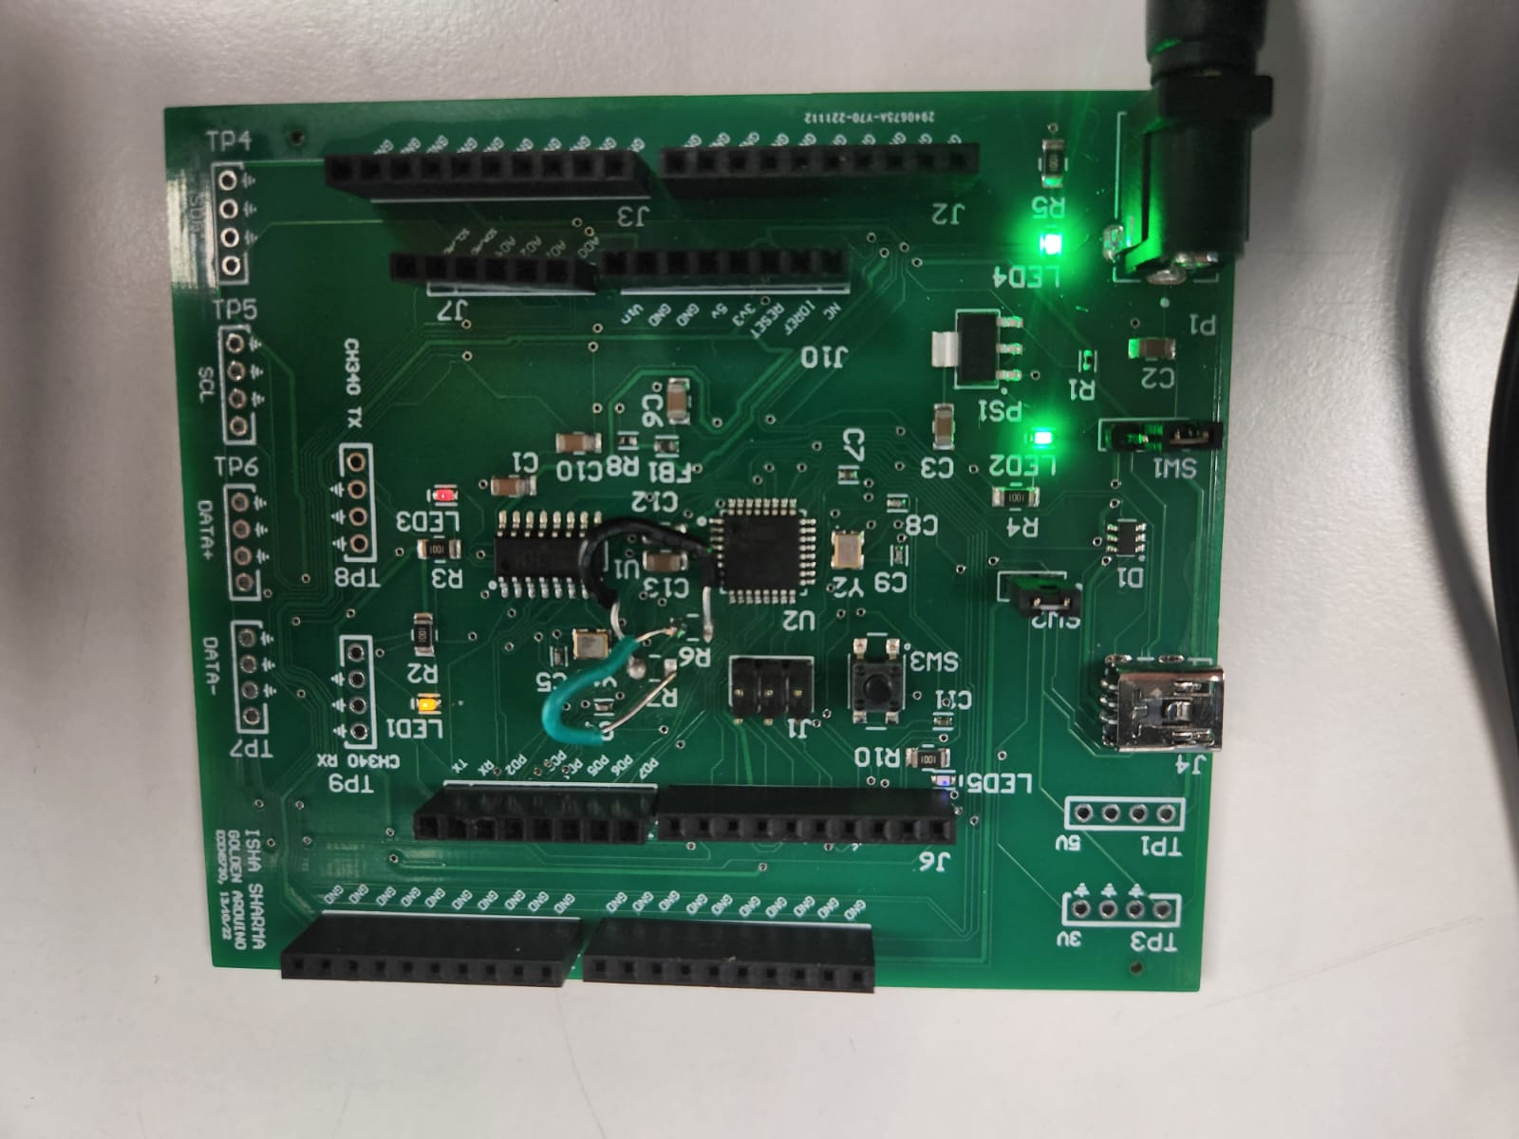

1. The blink code ran successfully on the board after.

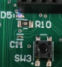 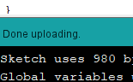

1. The shield light up when connected to the board.

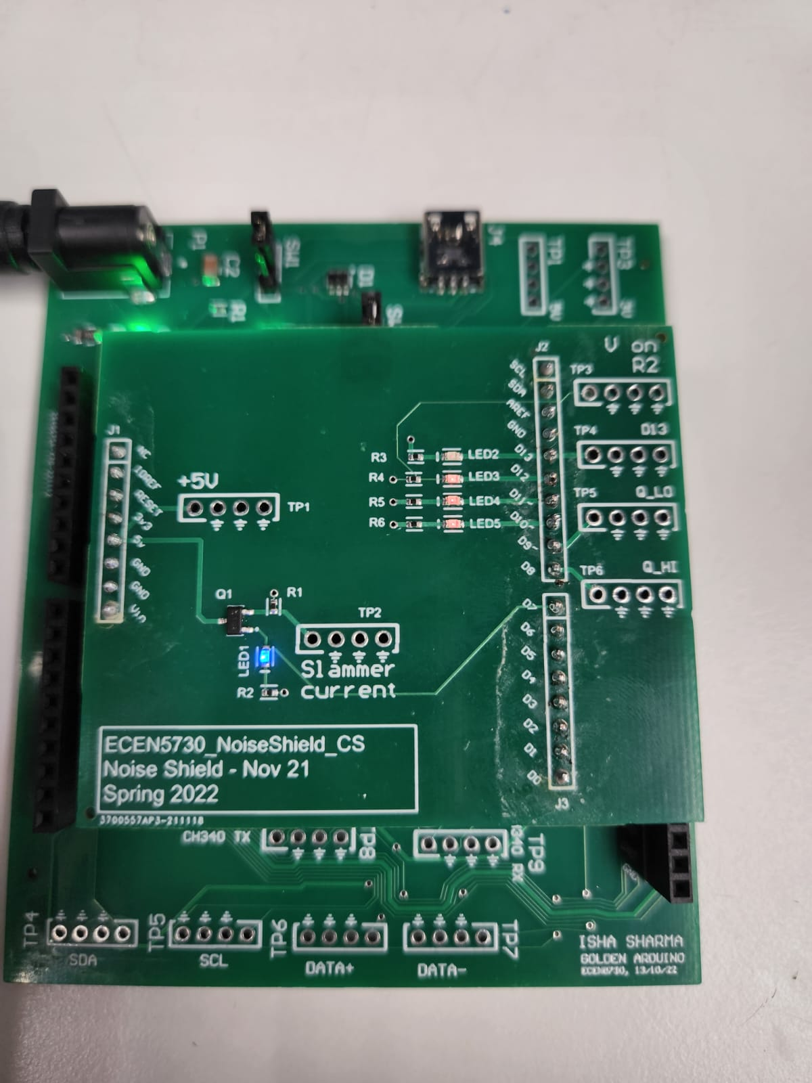

1. Comparison with Commercial Arduino: (in all the cases, the left side is the board and the right side is the commercial Arduino)
2. 5v power supply triggered with the D13 pin on the falling edge (yellow indicates D13 pin and blue/green indicates 5v)

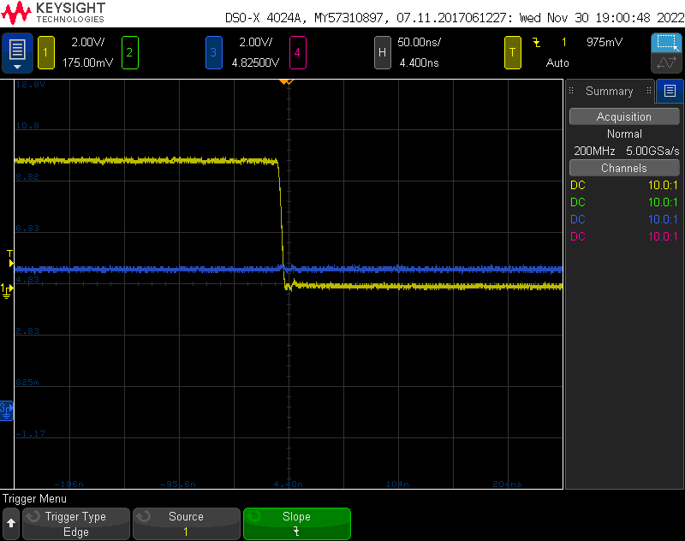 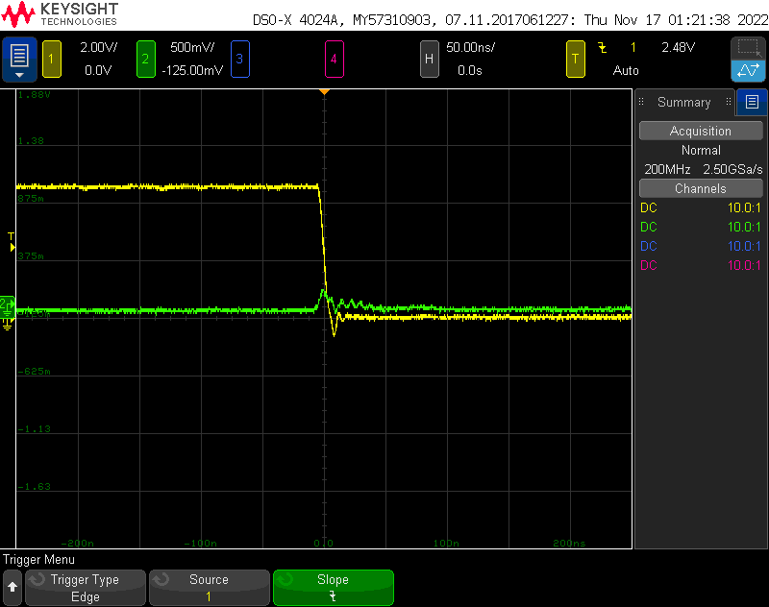

1. 5v power supply triggered with the D13 pin on the rising edge (yellow indicates D13 pin and blue/green indicates 5v)

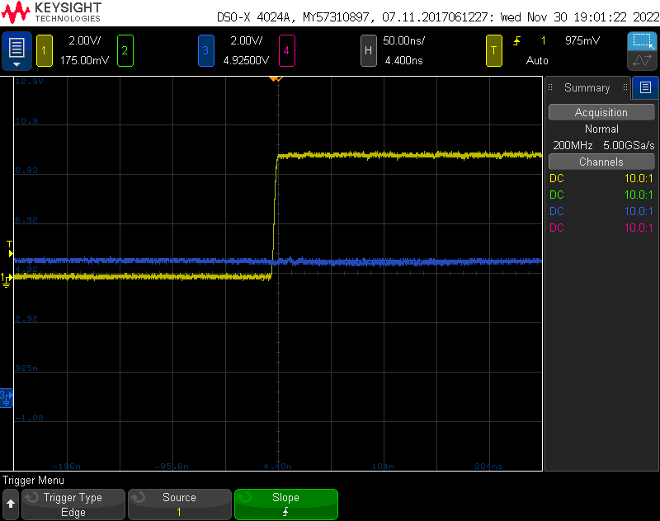 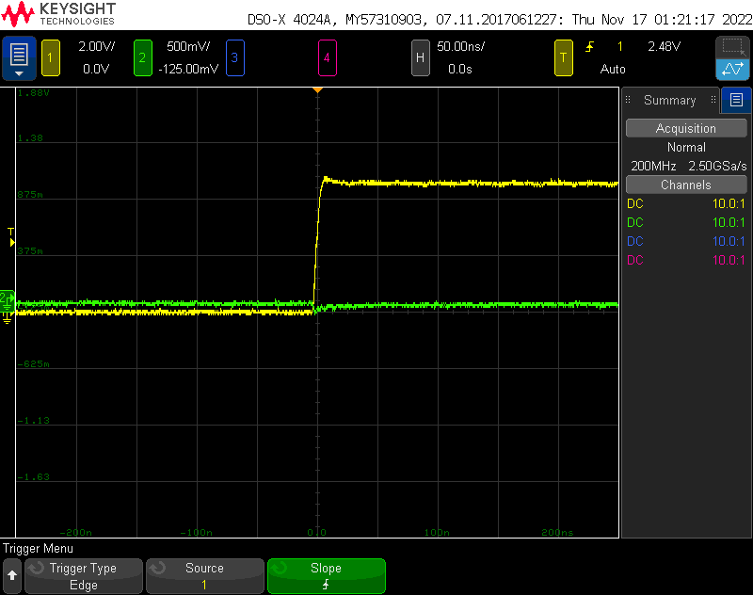

1. 63 ohm resistor (R2) triggered with the D13 pin on the falling edge (yellow indicates D13 pin and blue/green indicates R2)

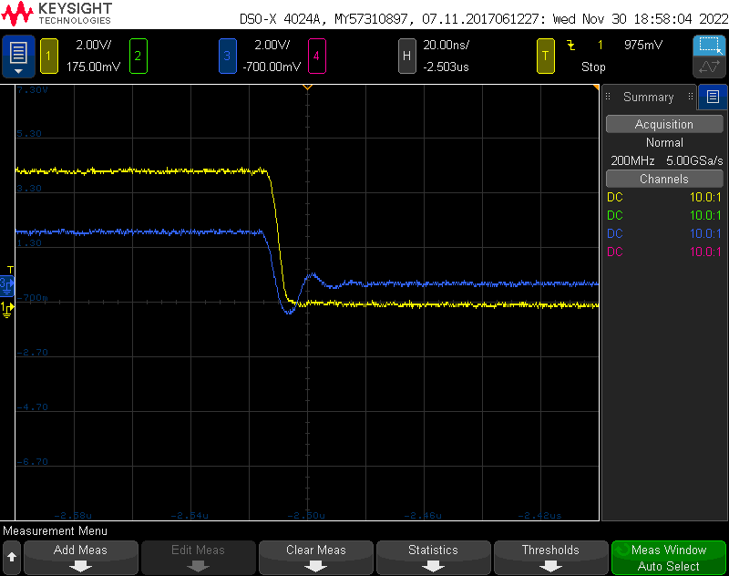 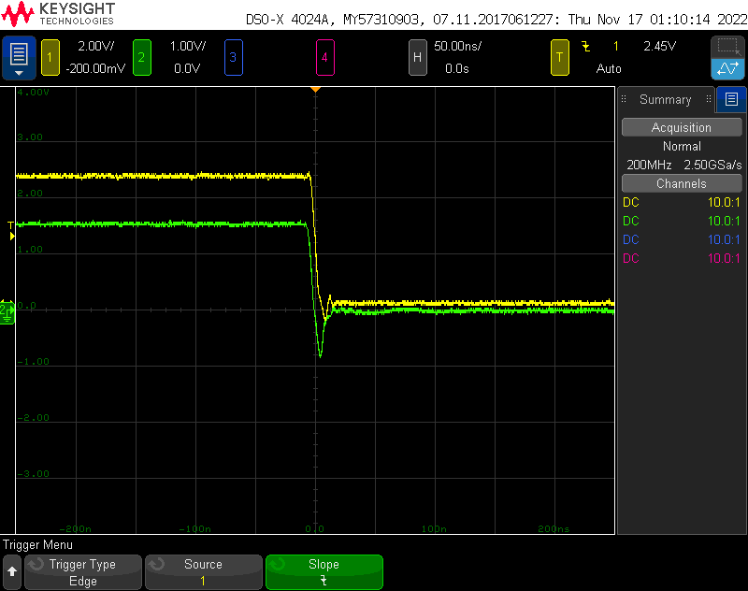

1. 63 ohm resistor (R2) triggered with the D13 pin on the rising edge (yellow indicates D13 pin and blue/green indicates R2)

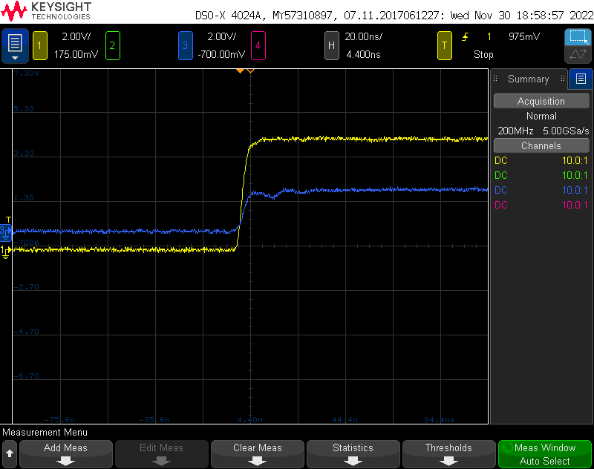 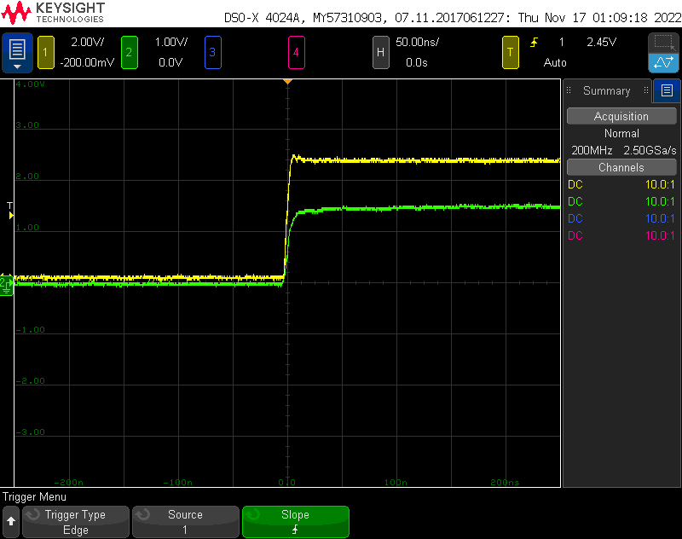

1. Qhigh triggered with the D13 pin on the falling edge (yellow indicates D13 pin and blue/green indicates Qhigh)

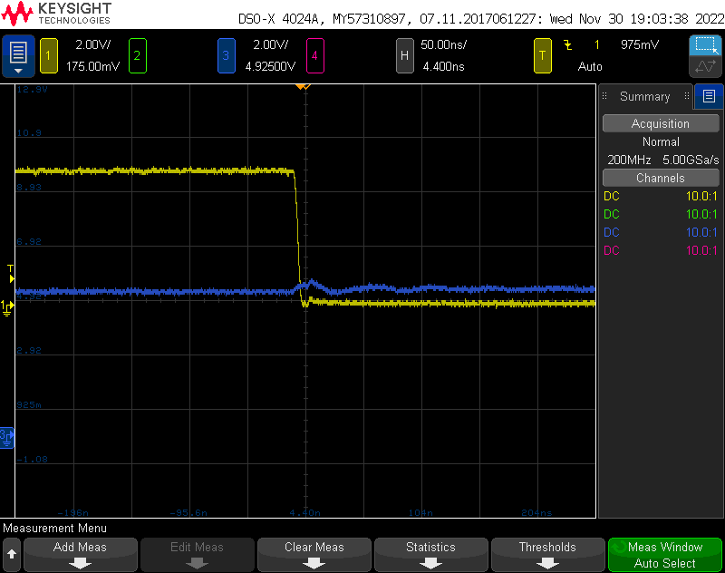 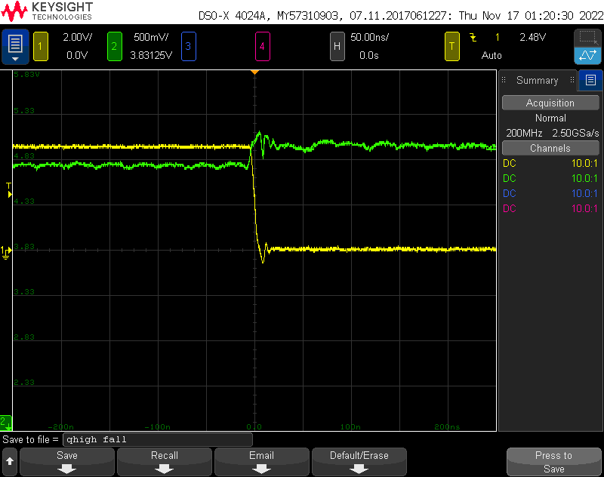

1. Qhigh triggered with the D13 pin on the rising edge (yellow indicates D13 pin and blue/green indicates Qhigh)

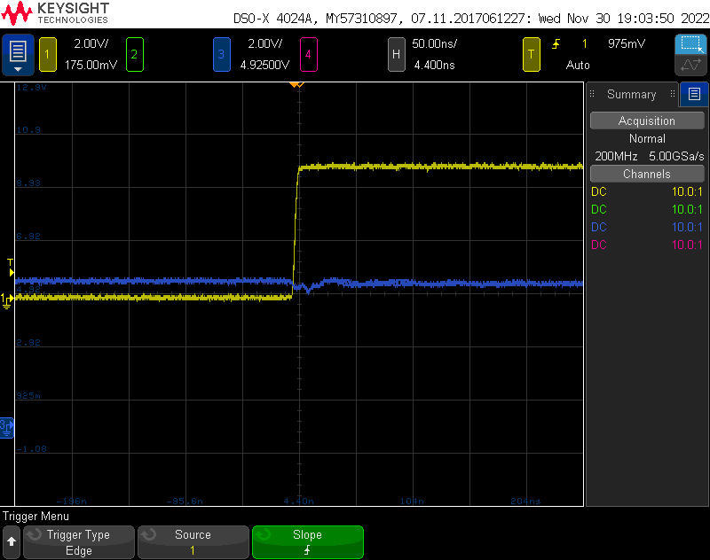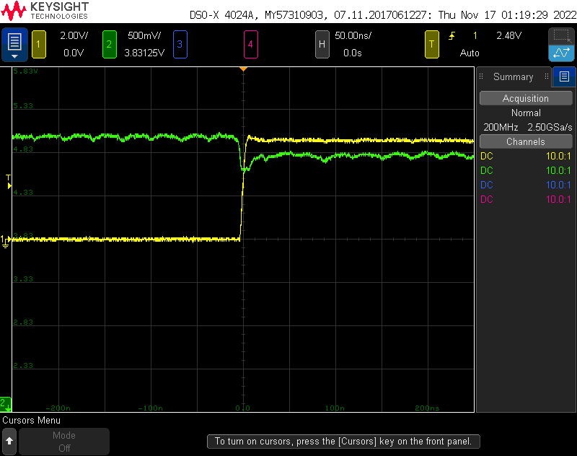

1. Qlow triggered with the D13 pin on the falling edge (yellow indicates D13 pin and blue/green indicates Qlow)

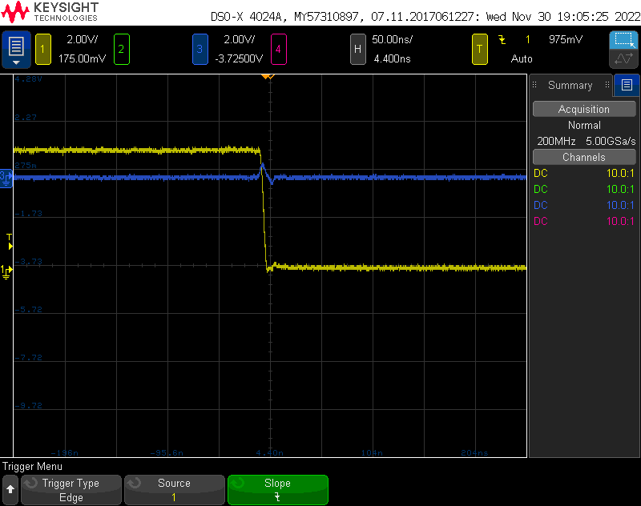 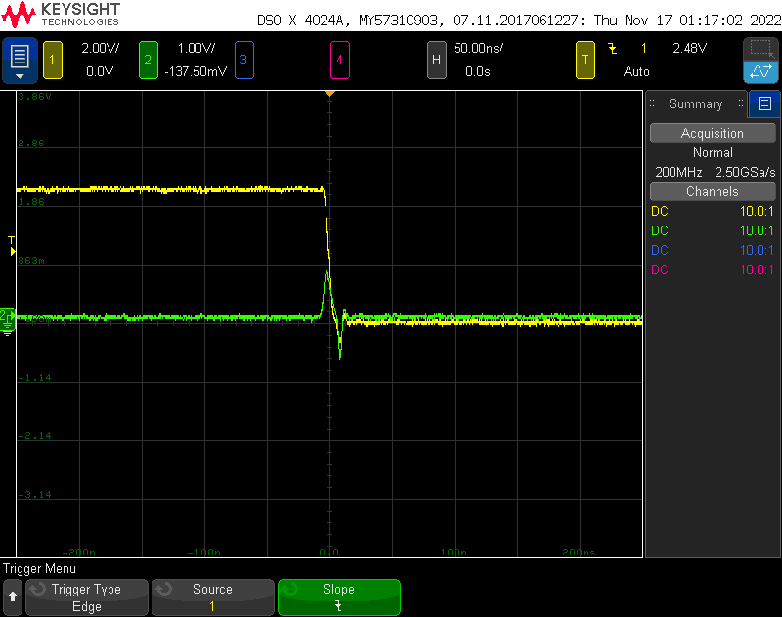

1. Qlow triggered with the D13 pin on the rising edge (yellow indicates D13 pin and blue/green indicates Qlow)

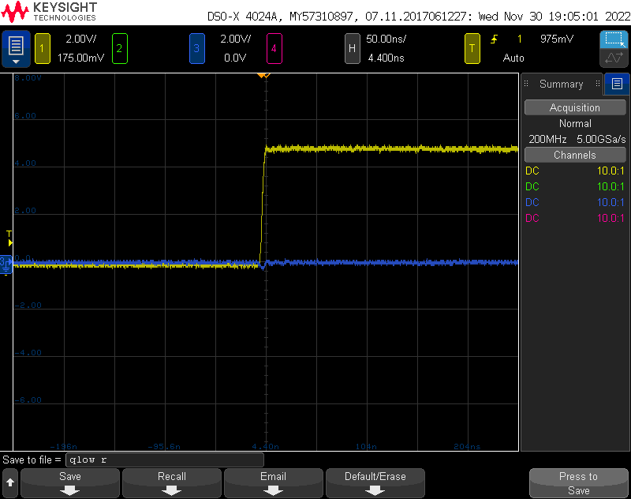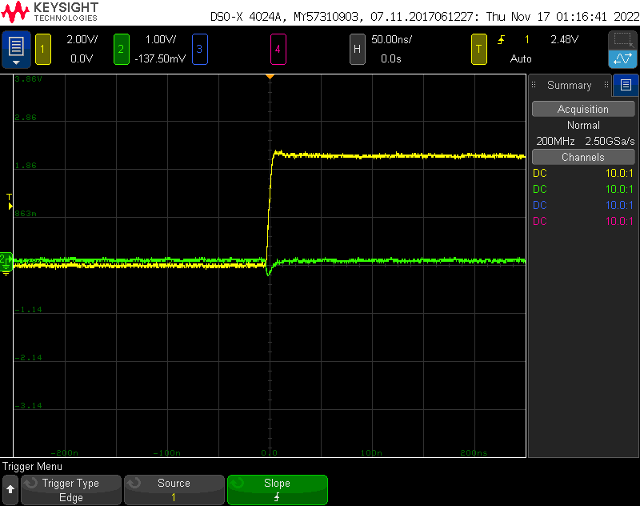

1. 5v power supply triggered with the Slammer Circuit on the falling edge (yellow indicates SC pin and blue/green indicates 5V)

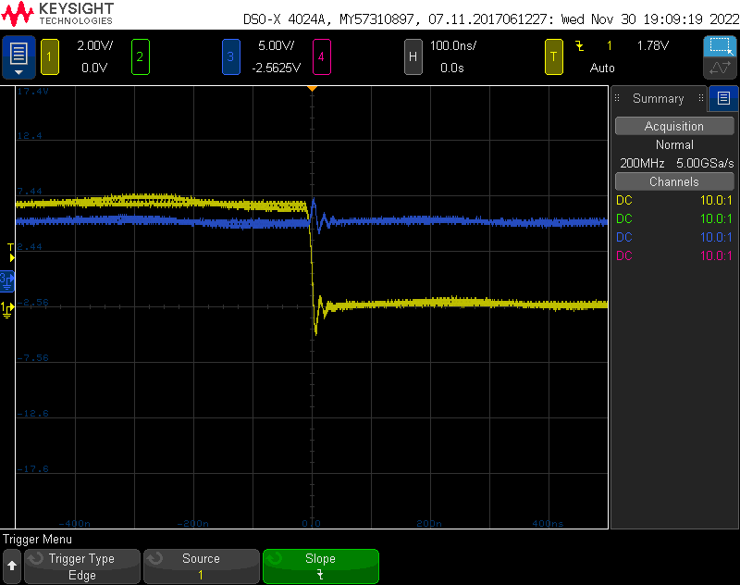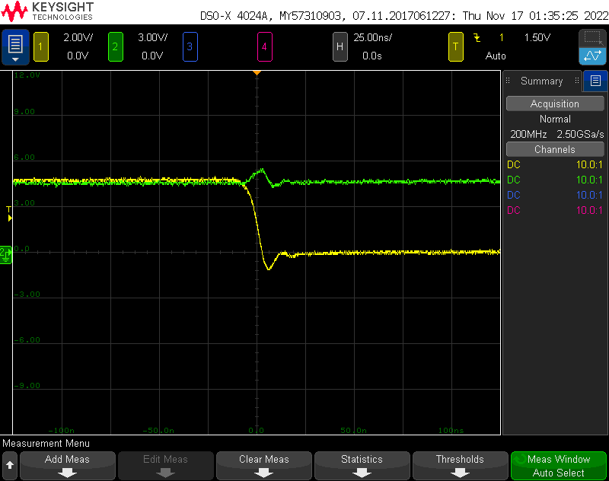

1. 5v power supply triggered with the Slammer Circuit on the rising edge (yellow indicates SC pin and blue/green indicates 5V)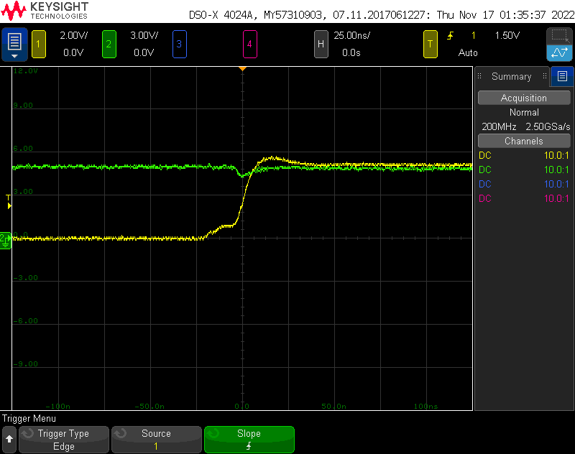

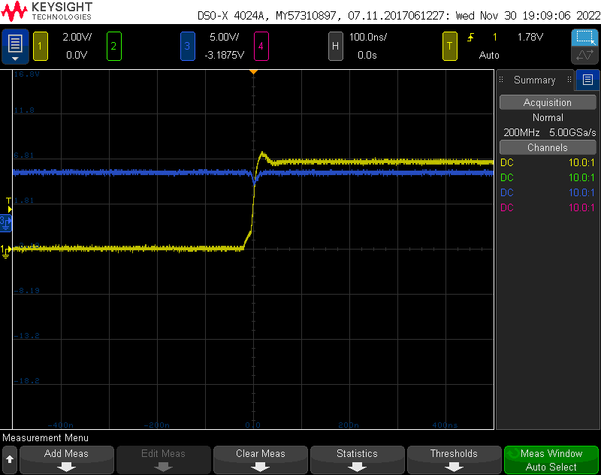

1. Qhigh triggered with the Slammer Circuit on the falling edge (yellow indicates SC pin and blue/green indicates Qhigh)

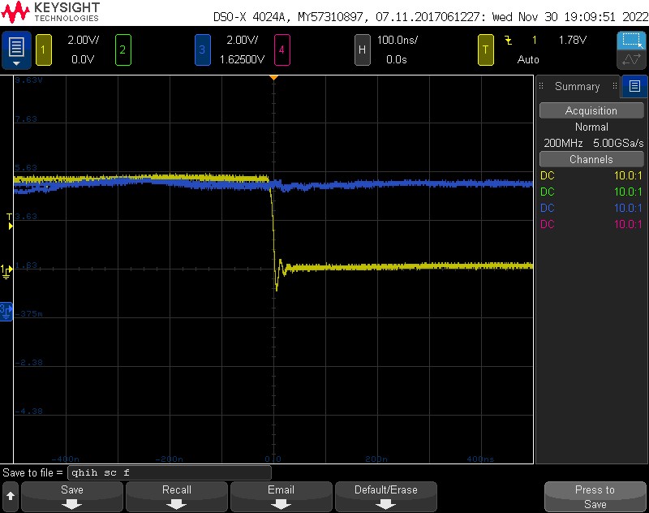 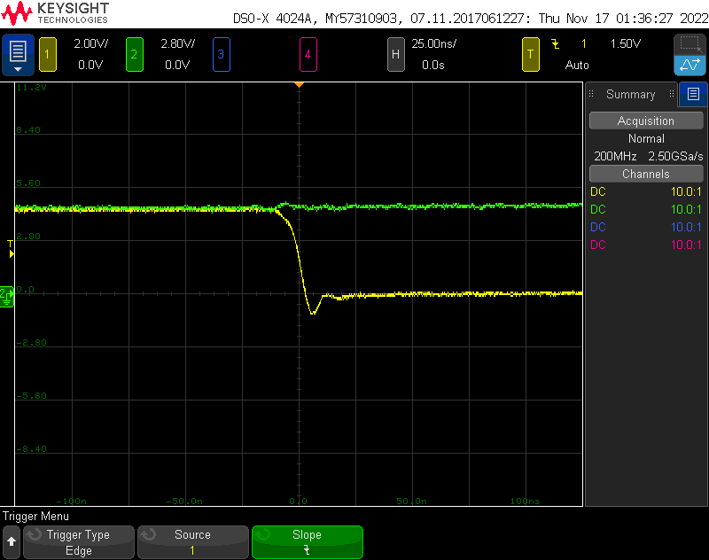

1. Qhigh triggered with the Slammer Circuit on the rising edge (yellow indicates SC pin and blue/green indicates Qhigh)

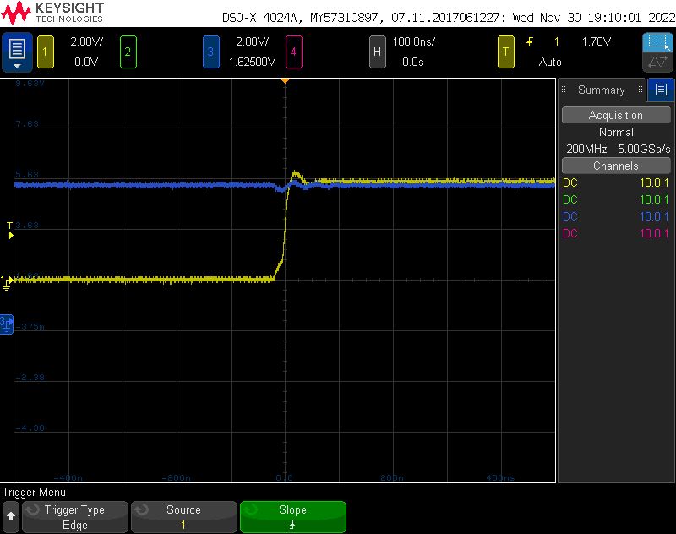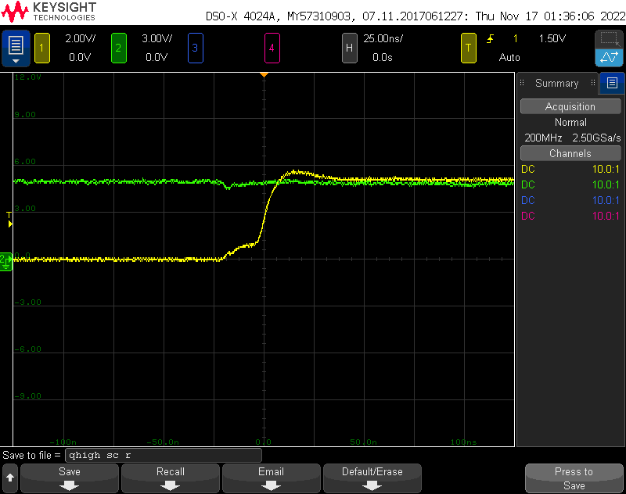

1. Near field emissions from bottom of the board (yellow indicates D13 pin and blue/pink indicates RF noise)

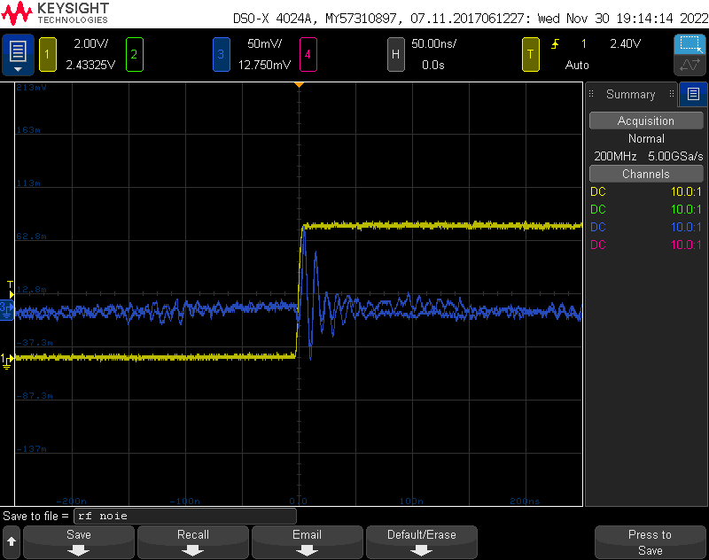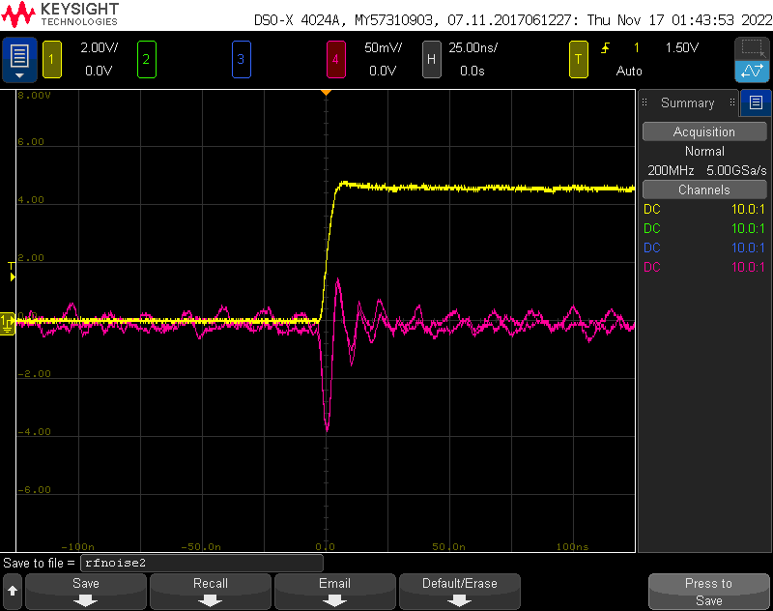

7) The inrush current for the board

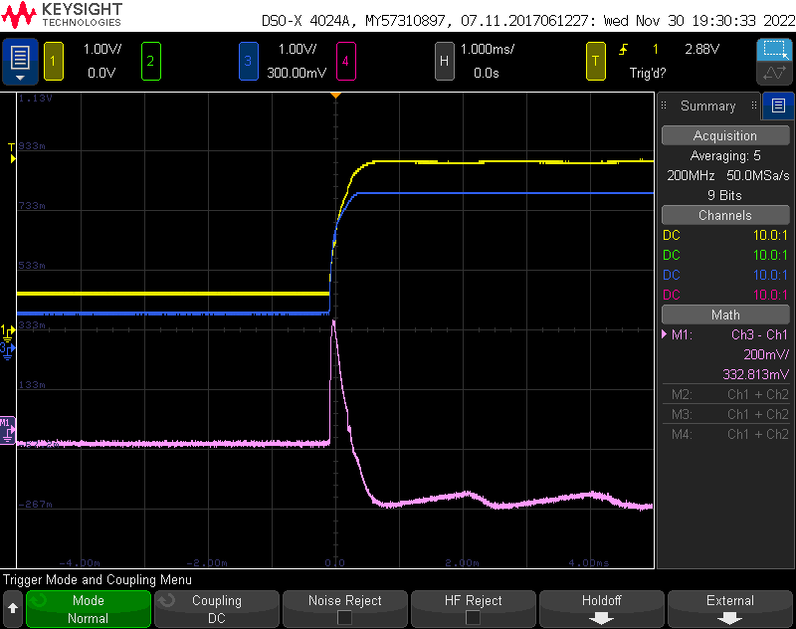

The current was measure to be 332.813mV/1ohm = 332.813 mA.

8) Other measurements:

Rise time for D13 pin: Arduino- 4.4ns / Board- 4.6ns

Fall time for D13 pin: Arduino- 4ns / Board- 4.3ns

Qlow values for fall time: Arduino- 800mV / Board- 500mV

Qlow values for rise time: Arduino- 30mV / Board- low signal

Qhigh value: Arduino- 490mV / Board- 500mV

Current across 63 ohms resistor: Arduino- 1.54/63=0.024A, Board- 4.8/63=0.076A

5v fall time when triggered with SC: Arduino- 20ns / Board- 25ns

5v rise time when triggered with SC: Arduino- 10.18ns / Board- 12ns

From the above outputs, it is clear that the noise from the board was comparatively less as compared to the commercial Arduino. This was done by using minimal number of cross-under length, continuous return paths for signal trace, keeping the crystal, filter capacitors and decoupling capacitors close to the Ics, keeping the Data traces short, keeping Tx and Rx traces short, top-layer signal and power routing, using ferrite filter on noise-sensitive pins, low loop inductance decoupling caps, routing adjacent signal lines as far from each other as possible to reduce cross-talk and noise.